Videos:

<https://www.youtube.com/watch?v=0_Nj-gQE0ZY&list=PLRGEvlJuGkp1_JXqmI2RZSy1qlxyxgbll>

Install:

Copy RdM Tools v2 folder in : pc/documents/maya/201X/scripts

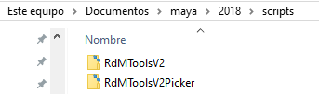

Run this command in **python**:

from RdMToolsV2.ShowUI import RdMV2UI

RdMV2_ui = RdMV2UI()

RdMV2_ui.show()

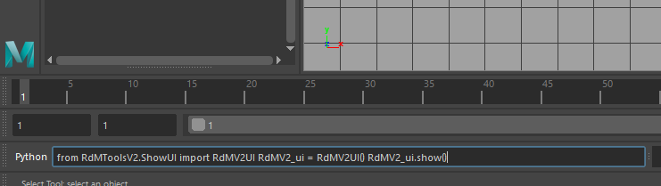

or

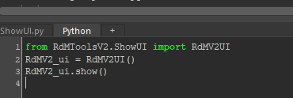

You can also open ShowUI.py form the scripts folder and run it (ctrl+enter)

For easy access create a icon in the shelf by drag and drop the code with the middle mouse!

Auto Rig:

Rigging Tools Tab

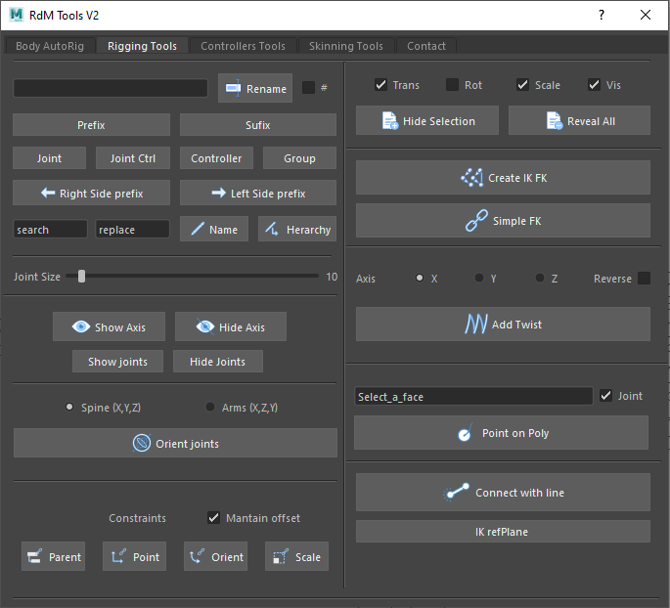

**Renamer**:

Rename the selected objects

# creates a number after the name

Prefix put the text line as prefix for selection

Sufix put the text line as prefix for selection

Joint, Joint Ctrol. Controller, Grp are premade Sufixes

Left and right side put L_ or R_ As perfix for selection

Search replace in selection or in the herachy

**Joint Size**: a slider that controls the size of the joints

**Show Hide**:

Show/Hide transform axis of the joints, if selected only shows those, else shows everything

Show/Hide Joints: Change the draw style from bone to none of all joints in the scene

**Orient joints**:

Select Joints and fast orient them in 2 different premade ways.

**Constraints**:

Constraints with or without maintain offset.

**Hide Attrs**:

Hide in the channel box the selected attributes

Reveal all the attributes in the channel box

**IK/FK**:

Select 3 joints chain (the chain must NOT have any parent or children) and create an IKFK Chain for them

**Simple FK**: Select Joints and create a FK Chain (Custom Axis is X)

**Add Twist:**

Select 2 joints and creates a twist between them with the selected axis

Use Reverse for lower arm kind of twist and don't use it for upper arm kind of twist

**Point on Poly**:

Select a Face and connect a Locator to the mesh. It can have a joint if needed

**Connect with Line**:

Select 2 objects and connected with a curve

**ikPlane Ref**:

Select 2 objects and create a plane between them, ideally for creating IK systems

Controllers Tab

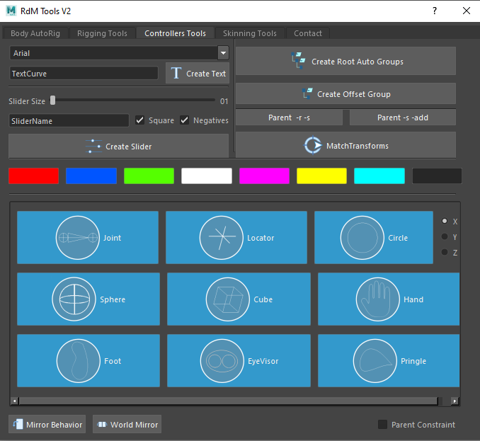

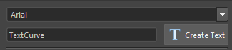

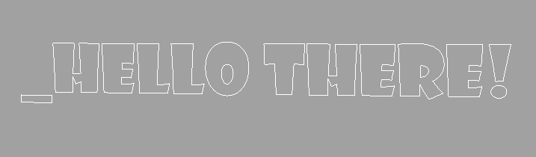

**Curve Texts:**

Select a font and create curves with the text (there is a warning sometimes, just ignore it ;D)

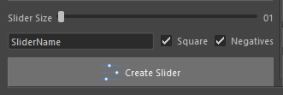

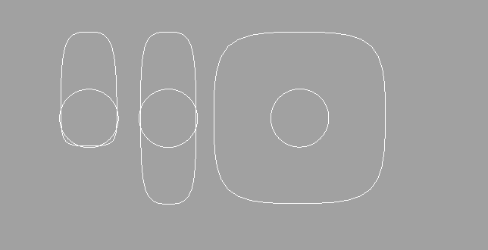

**Create Sliders with curves**:

Select the size (translate Y and X limits), use it with Negatives and or with square Shape. The NAME MUST BE UNIQUE!

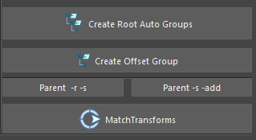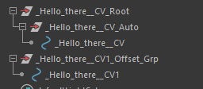

Select objects and create an **Root and Auto** Groups above them (2 groups)

Select objects and create an **offset group** above them (1 group)

**Change chapes** from transform nodes

**Add shapes** from transform nodes

**Match Transforms:** Select the object you want to move and the desire position then match the transformations

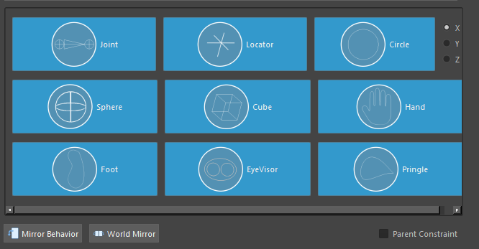

**Curves:**

Create Curves with selected shape. You can select objects and create the curve on their positions wit or without parent constraints!

**Mirror Behavior:**

Create a group over the selected object to change their axis to the other side

**World Mirror:**

Move the selected object to the other side of the world in X axis.

Skinning Tab

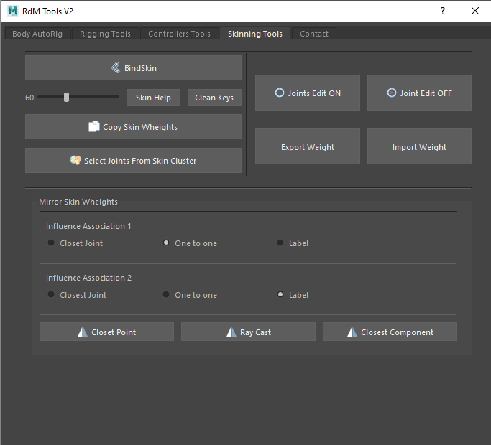

**Bind Skin**: Simple bind skin for selected objects

**Skin Help**: Select the angle and Create keyframes with rotations for easy skinning

**Copy skin Weights**: Select two objects and copy the skinning

**Select joints from Skin Cluster**: Select the joints from selections with skin clusters

**Joints Edit**: Turn on and move the bindend joints, turn of and save the changes

Export Weight: Export or import the weights maps (Don't use them, there are better ones online)

**Mirror Skin Weights**: Mirror skinning in X Axis (Closes component is the recommended)

Contact Tab

Contact me anytime :D

feel free to email me from the form or just use this methods

I read all the emails!

+506 85825945 info@renderdemartes.com